St Matthew’s Church of England Primary School
with
Brunel Nursery School

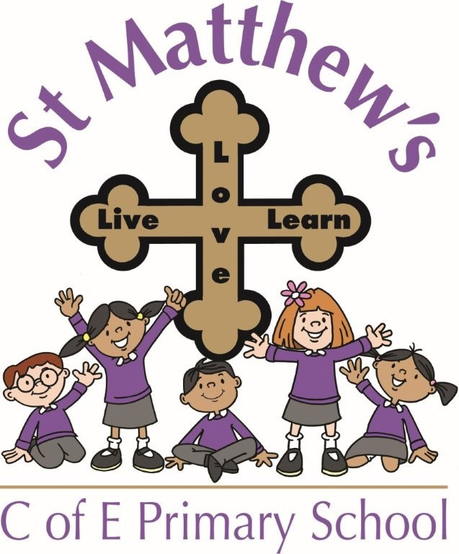
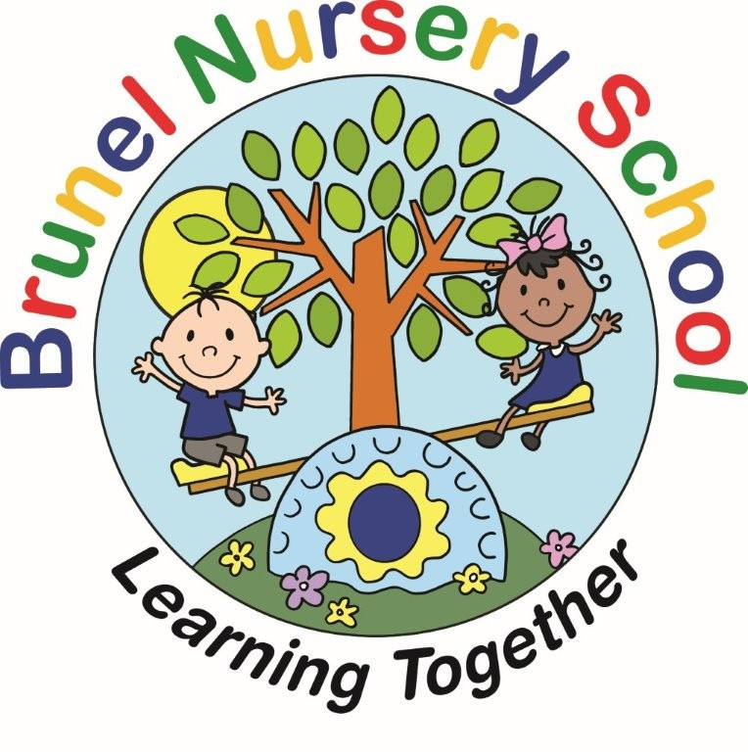

Policy for Early Years Foundation Stage

St Matthew’s Church of England Primary School mission statement
We aim to deliver a positive learning experience in a safe and respectful environment. We strive to teach an inspiring and inclusive curriculum that promotes a love of learning. As a Christian school, we endeavour to develop the spiritual and moral values of all members of the St Matthew’s family, and a meaningful, loving relationship with God. We want our children to be cheerful and independent individuals who reach their potential and are proud of their achievements. We hope to develop confident, caring citizens who are well prepared to live happy and rewarding lives.

Our motto: Live, Love, Learn

Brunel Nursery School’s mission statement
We aim to deliver a positive learning experience in a safe and respectful environment. We strive to teach an inspiring and inclusive curriculum that promotes a love of learning. We want our children to be cheerful and independent individuals who reach their potential and are proud of their achievements. We hope to develop confident, caring citizens who are well prepared to live happy and rewarding lives.

Our motto: Learning Together
Policy Reviewed
Date | By Whom
25.09.25 | Governors of the Achievement Committee
Date for next review: Sept 2026

Foundation Stage

The Early Years Foundation Stage applies to children from birth to the end of the reception year.
At St Matthew’s CE Primary with Brunel Nursery the Foundation Stage begins when children reach the age of three and start at Brunel. In the September before they turn five, nursery children move up to St Matthew’s Robins Reception class, or onto other Reception classes for their next stage of EYFS learning, which, through this year increasingly prepares them for moving to Year 1 and the more formal learning context of the KS1 curriculum.

At St Matthew’s CE Primary with Brunel Nursery we aim to create a welcoming, well-planned learning environment which encourages children to be curious, develop their interests and explore learning through first hand experiences. We also aim to make it a place where children feel secure and confident, and are motivated to develop their independence. We support and encourage our children to become independent learners who can initiate their own lines of enquiry and investigation through play.

Starting at Brunel Nursery

Children begin in the Nursery when they have turned 3 years of age, and so may join us in the Autumn, Spring or Summer terms. We start children at their own individual pace and readiness to part from their Parent/Carers, supported by their Key Worker. To begin with this may mean children attend for shorter times and this is gradually increased as their confidence and readiness grows to allow them to attend happily for their full session.

Starting Reception

Children begin the Reception Class in the September of the school year in which they turn 5 years old. Please see our Admissions policy for more information. Our admission arrangements are carefully organised and regularly reviewed to ensure that all parties are happy, confident and fully informed about all aspects of induction.

We value the importance of a positive introduction to school for both children and Parents/Carers.
Towards the end of the Summer Term Nursery children moving to St Matthew’s Reception Class have the opportunity to meet and spend time with their new class teacher in the Robins’ classroom environment. Parents/Carers will also have the opportunity to attend a meeting with the Robins staff.

Aims of the Foundation Stage

- To make each child’s first experience of nursery and school happy and positive.
- To provide an EYFS learning environment that is safe, stimulating and nurturing,
- To ensure that all children feel valued and cared for.
- To promote children’s confidence, independence, and motivation to learn and make progress.
- To provide a balance of high-quality child initiated and adult led activities.
- To deliver a progress-driven curriculum aimed to enable each child to develop personally, socially, emotionally, spiritually, physically, creatively and intellectually to his/her full potential.
- To ensure our curriculum model remains flexible and consistently based on children’s particular learning needs, interests and knowledge.
- To promote a partnership between home and school in order to establish an accurate understanding of each child’s individual needs. (Parents as partners)
- To work within the guidelines of the Early Years Foundation Stage (EYFS)

The Early Years Foundation Stage is based upon four themes:

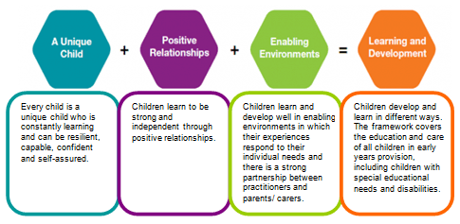

Our practice is underpinned by these four themes.

A UNIQUE CHILD

‘Every child is a unique child who is constantly learning and can be resilient, capable, confident and self-assured.’
‘Statutory Framework for the Early Years Foundation Stage’

At St Matthew’s CE Primary School with Brunel Nursery we believe all our children are unique. We give each child the opportunity to achieve their best by:

- Providing a secure, ‘Enabling Environment’ for our children to practise their skills and develop their learning.
- Planning activities and experiences that are firmly-based upon children’s individual learning needs and fascinations.
- Promoting a sense of belonging using resources and materials that reflect our children’s lived experiences and communities.
- Recognising children develop and learn at different rates and celebrating and valuing all children’s achievements, progress and contributions.

Inclusion

All children at St. Matthew’s CE Primary with Brunel Nursery are treated fairly regardless of race, gender, religion or abilities. We value the diversity of individuals within our school as we believe that all our children matter. We give our children every opportunity to achieve their best by taking account of the range of life experiences our children have when planning for their learning.

In the Early Years Foundation Stage we set realistic and challenging expectations that aim to meet the needs of all our children, including children with special educational needs, those who are more able, children with disabilities, children of different social and cultural backgrounds, boys or girls, and those of different ethnic groups.

Special Educational Needs

We aim to identify any special educational need early on in order that children may benefit from targeted, additional support with their learning within the classroom environment. This may happen in regular small group intervention or as 1:1 support in line with the Special Educational Needs Policy. The class teacher or key worker will discuss any targets identified with the child’s parents/guardians on a regular basis.

Welfare

‘Children learn best when they are healthy, safe and secure, when their individual needs are met and when they have positive relationships with the adults caring for them.’
‘Statutory Framework for the Early Years Foundation Stage’

The safety of our children is paramount at St. Matthew’s CE Primary with Brunel Nursery. We aim to educate children on boundaries, rules and limits and help them understand why these exist. We provide children with choices to help them develop this important life skill. Children are encouraged to take risks in order to aid their own learning, but need to be taught how to recognise and avoid hazards.

At St. Matthew’s CE Primary with Brunel Nursery School we:

- Promote the welfare of children.
- Promote good health, preventing the spread of infection and taking appropriate action when children are ill.
- Manage behaviour effectively in a manner appropriate to our children’s stage of development and individual needs.
- Ensure all adults who look after the children or who have unsupervised access to them are suitable to do so.
- Ensure that the premises, furniture and equipment is safe and suitable for purpose.
- Ensure that every child receives enjoyable and challenging learning experiences tailored to meet their needs.
- Maintain records, policies and procedures required for safe efficient management of the setting and to meet the needs of the children.
POSITIVE RELATIONSHIPS
We aim to develop caring, respectful, professional relationships with our children and their families. All staff involved within the Early Years Foundation Stage promote good relationships with all children, responding to their particular interests and learning needs and interacting positively with them. We understand the key importance of language in our children’s wider learning, particularly those having English as an additional language, and place importance on taking time to talk, listen and have quality conversations with them.

Parents as Partners

We recognise Parents as the first and most important educators of their child. We encourage parental involvement in all aspects of learning and encourage a partnership based on mutual trust and respect by:

- Inviting Parents/Carers and children to meet Key Workers and teachers and visit Brunel Nursery and St Matthew’s CE Primary Reception class before children start school with us.
- Talking to Parents/Carers about their child’s interests, level of skills and any perceived challenges or barriers to learning.
- Inviting Parent/Carers to participate in workshops, open mornings and other in-school activities throughout the year.
- Prioritising good channels of communication with Parent/Carers to share and discuss attainment and progress or any queries or concerns.
- Sharing the learning that takes place throughout the year using termly newsletters and stay and plays where parents can contribute to their child’s learning within the school and nursery setting.
- Offering a minimum of two Parent/Teacher consultation meetings in each year to discuss children’s attainment and progress and engage Parent/Carers in the supporting of targets in true Parent/school partnership.
- Sending home written reports of each child’s attainment and progress, such as at the end of the Nursery and Reception years.

ENABLING ENVIRONMENT

St. Matthew’s CE Primary with Brunel Nursery provides children with well-planned indoor and outdoor environments in the Nursery and Reception class, offering a range of opportunities and challenges for independent and supervised exploration and experiences in all areas of learning. We aim to promote children’s curiosity and confidence and provide activities for them to practise and make progress in their learning and skills, encouraged and supported by experienced EYFS staff.

Ours Early Years Foundation Stage environments provide Continuous Provision areas in which our children are encouraged and supported to:
- Develop language to communicate their thinking and ideas.
- Engage in social or imaginative play or group games with friends.
- Build their ‘gross motor’ skills by being physically active outdoors.
- Develop their ‘fine motor’ control with ‘finger gym’ activities and small-scale construction.
- Explore their ideas of shape space and measures using a range of resources including large-scale construction and sand and water play.
- Put into practice what they have learned about number and number patterns.
- Focus on quieter activities such as looking at books and working on puzzles and challenges.
- Develop their understanding of story language and structure using toys to re-tell familiar stories.
- Practise their emergent writing using a differentiated range of mark-making equipment indoors and outdoors.
- Put into practice their learning about letters and sounds using phonics resources.
- Explore and learn about the natural world around them.
- Investigate materials such as soil, dough, pasta, rice, gloop and water both indoors and outdoors.
- Develop their creative skills and ideas with art and crafting, musical and expressive activities.

The Indoor Classroom:
We aim to ensure that the indoor environment:
- Has areas suitable for quiet learning, sharing books, and focussed individual or paired/group learning.
- Encourages children to take a pride in and responsibility for their environment and to develop independence in the selection, care and return of resources and equipment.
- Is well-ventilated, regularly sanitised and promotes hygienic practices, including hand-washing and provision of a healthy snack.

The Outdoor Classroom
We aim to ensure that our outdoor environment:
- Offers opportunities for fresh air and physically active play in a secure environment.
- Provides opportunities to practise and explore all areas of learning in livelier, less-restricted ways.
- Provides some covered and shaded areas.

LEARNING AND DEVELOPMENT

‘Every child deserves the best possible start in life and the support that enables them to fulfil their potential. Children develop quickly in the early years and a child’s experiences between birth and age five have a major impact on their future life chances. A secure, safe and happy childhood is important in its own right. Good parenting and high quality early learning together provide the foundation children need to make the most of their abilities and talents.
‘Statutory Framework for the Early Years Foundation Stage’

At St. Matthew’s CE Primary with Brunel Nursery we plan carefully structured, progress-driven educational programmes based on the EYFS learning and development requirements.

The EYFS is divided into 7 areas of learning and development that shape educational programmes. All are important and interconnected however, three areas are particularly key for igniting children’s curiosity and enthusiasm for learning, and for building their capacity to learn, form relationships and thrive.

These 3 Prime Areas, are:

• Communication and Language;
• Physical Development
• Personal, Social and Emotional Development.

There are 4 Specific Areas, through which the three prime areas are strengthened and applied. These are:

• Literacy
• Mathematics
• Understanding the world
• Expressive Arts and Design

Communication and language underpins all seven EYFS areas of learning and development. Quality interaction with adults who model vocabulary and sentence structures in context and talk about what children are doing or what interests them is key to language development. Adults also engage children in books, stories and rhymes; story-telling and role play and encourage conversations, prompting children to share their ideas, elaborate and begin to use an increasingly rich vocabulary and language structure.

Personal, social and emotional development is crucial to children leading happy and healthy lives. This is developed as adults model and guide children to form good relationships; understand their own, and others’, feelings; help them to manage their emotions; develop a positive sense of themselves and their own abilities and learn to look after their bodies with healthy eating and by managing their own personal needs.
Physical development is key to children’s all-round development. Children’s ‘gross motor’ skills provide the foundation for them developing healthy and active bodies and their social and emotional well-being. This is developed as adults support children to develop their core strength, stability, balance, spatial awareness, co-ordination and agility with regular and varied games and activities outdoors.
Children’s ‘fine motor’ control and precision is the basis for hand-eye coordination and early writing skills. This is developed as adults support children to develop finger strength and control with a wide range of activities and opportunities to build proficiency using small tools, art and craft, puzzles and small world toys.

Literacy encompasses early reading and writing which, in turn, rely on the language comprehension children develop through listening to adults talk to them about their world, read books and share rhymes, poems and songs.‘ Word Reading’ skills are then taught with systematic phonics, developing children’s decoding and ‘speedy recognition’ of familiar words. Writing requires children to have developed their ‘fine motor’ control and precision. Adults encourage children in their mark-making and drawing and the progression to forming some familiar letters in their emergent writing. Children progress to articulating their ideas in writing, using phonemically plausible spelling at first and writing simple sentences.

Mathematics in the EYFS involves children learning to count with confidence and develop a deep understanding of the numbers to 10. Adults support children to recognise the relationships between numbers 1-10 and the patterns within them. Children are also encouraged to develop their spatial reasoning skills and understanding of shape, space and measures. Adults provide frequent and varied opportunities for children to build and apply their understanding, fostering a positive attitude and interest in mathematics; encouraging children to ‘have a go’ and not be afraid to make mistakes; spot patterns and connections; and talk about what they notice.

Understanding the World involves adults to guide children in making sense of their physical world, their community and their ‘past’ and ‘present’. Adults develop children’s understanding by sharing and talking about non-fiction books, rhymes, stories, poems and technology and engaging with them in themed role play and learning. Children benefit greatly also from personal experience visiting parks, gardens, libraries, doctor and dentist surgeries and shops and opportunities to meet police officers and firefighters. In developing children’s awareness of their culturally, socially and ecologically diverse world adults aim to extend and enrich children’s vocabulary, which in turn supports their later reading comprehension.

Expressive arts and design aims to develop children’s artistic and cultural awareness and promote their imagination and creativity. The quality and variety of what children see, hear and participate in is key to developing their understanding, self-expression, vocabulary and ability to communicate through the arts. Adults provide regular and varied opportunities for children to explore, play and create with a wide range of media and materials and plan activities that support progression in children’s skills interpretation and appreciation of what they hear and observe.

‘Statutory Framework for the Early Years Foundation Stage’

At St Matthew’s CE Primary with Brunel Nursery we believe these seven areas depend on each other to support a rounded approach to child development and progress in learning. Children learn in many different ways and we recognise the need to provide opportunities that allow children to learn in the ways that best suit them ~ playing, talking, observing, investigating and problem solving, questioning, experimenting, testing, repeating, reflecting and responding to adults and each other. Our educational programmes are delivered through a combination of adult-led focussed learning and child-chosen/child-initiated activities. The learning may be delivered through a wide variety of activities aimed at the whole class, groups, pairs or individuals that take place both in and out of doors.

Planning
We design a broad and rich educational programme based on our sound assessment and knowledge of children’s learning needs, life experiences and interests. We base our planning on what our children know and can do already and what we aim for them to know and do. We use Development Matters and Birth to Five to guide, but not limit, this progression-planning, setting out the skills and knowledge we want children to develop throughout the year to prepare them for their next stage in learning.
Long term planning
Our long term planning covers all 7 EYFS areas of learning and sets out what we intend children to learn progressively through the year. We aim for learning intentions to be ambitious and appropriate to the cohort of children and their life experiences. Long term planning sets out the possible themes and experiences we intend to introduce to children, but remains flexible, so as to be appropriate to our children’s changing learning needs, their particular fascinations and to make the most of unforeseen learning opportunities.

Medium term plannng
Our medium term planning identifies the steps in learning, we intend to teach, practice and develop progressively throughout each half term in all EYFS areas of learning.
In Nursery, this planning includes the ‘Tier 2’ vocabulary we teach children in the context of learning themes. In Reception, it includes the English, Mathematics and phonics teaching sequences that will be taught and identifies the ‘core’ story, non-fiction book or overarching learning theme to be explored. Our planning model recognises that children make the best progress in their knowledge and skills when they are given repeated and varied opportunities to practice and secure their knowledge and skills in different contexts.

Short term planning
Our short term planning identifies how we will implement learning intentions using particular activities, experiences and adult teaching interactions. In Nursery free-flow play, guided by quality adult interactions and adult-led learning times, is at the heart of our educational model. In Reception a more formal model of teacher-led group learning is systematically introduced alongside enjoyable and motivating opportunities for children to practise and explore their understanding and skills in planned Continuous Provision. Reception planning may identify those children receiving ‘Keep Up Not Catch Up’ group intervention, those having Special Educational Needs, linked to their individual targets, and those children receiving speech and language intervention or bilingual support.

Characteristics of Effective teaching and Learning skills are of fundamental importance to children’s on-going and future learning as stated in the Statutory Framework for the EYFS.
Our educational model plans and promotes children’s continuous progress in their key skills of:

Playing and exploring – engagement
Finding out and exploring
Playing with what they know
Being willing to ‘have a go’

Active learning – motivation
Being involved and concentrating
Keeping trying
Enjoying achieving what they set out to do

Creating and thinking critically – thinking
Having their own ideas
Making links
Choosing ways to do things

Assessment
Assessment is key to recognising children’s progress, understanding their learning needs and providing appropriate learning activities and support. Ongoing ‘formative’ assessment is an integral part of daily adult-child ‘in the moment’ teaching interactions in the EYFS, allowing adults to gain understanding of a child’s current attainment in order to support, secure and plan how to extend this. Teachers also appraise and record children’s progress in ‘summative’ assessments at specific times during the Nursery and Reception Years and this feeds into school assessment data.
We keep Parent/Carers informed about their child’s progress through regular Parent-Teacher meetings and school reports.

- In Nursery, assessment of children’s attainment in the Prime Areas of Communication and Language, Physical and Personal, Social and Emotional development are carried out by Key Workers on entry and at specific ‘check-points’. This allows us to identify those children who are ‘on track’, behind or delayed in expected attainment in order that gaps in learning can be prioritised and children helped to make appropriate steps in progress.
- In Reception, teachers assess children’s starting points on entry using end of Nursery Year data and End of Year report; discussion with Nursery Key Workers and by carrying out Baseline assessments. A statutory Baseline Assessment (RBA) is additionally carried out to provide a starting point from which children’s progress in literacy, language and communication and early maths will be measured through the primary school.
- An EYFS Profile is completed for each pupil at the end of Reception Year. This provides a well-rounded picture of each child’s knowledge and attainment against the EYFS Early Learning Goals and of the child’s readiness for starting Year 1. Profile information is shared with Parent/Carers and the Year 1 Class Teacher and the Profile data is also sent to the local authority.

Rebecca Wogden
Foundation Stage Leader
St Matthew’s CE Primary with Brunel Nursery School
September 2025

