EYFS 6: Stories Jesus Told

Why did Jesus tell stories?

Christian Concepts
God – Creation – Fall – People of God – Incarnation – GOSPEL – Salvation – Kingdom of God

The aim of this unit is to:
- explore the stories that Jesus told and know that he told them to teach us about God.

Christian Values
Compassion Love Faith

Key Vocabulary
Jesus, Bible, parable, gospels and God

Key Questions
- Where will you find the stories which Jesus told?
- To whom did he tell these stories?
- What do the stories teach us?
- Why did Jesus tell stories?

Content to be covered in this unit
- Jesus told important stories called parables.
These stories can be found in the Bible.
Jesus told these stories to teach us about God and how to live our lives.
- The stories of ……
The Good Samaritan
The Sower
The Great Feast
The Lost Sheep
The Wise and Foolish Builders
The Lost Coin
- You may decide not to tell some of these stories it will depend on where the children’s interest takes you.

Objects for Your Chatterbox
- Bandages and plasters
- A charity logo/posters
- A few Sheep
- Shepherd’s Clothing (Nativity Costume)
- Coins – Old or Foreign
- Small world people or playmobil figures eg Farmer, fireman or nurse
- Unmarked seeds in a clear sealed bag
- Party Invitations
- 2 toy/model houses or a brick
- Sand
- Storybooks of the parables
- Eggsplorers – ask Wendy.

To Begin with/ First Lesson
Chatterbox
Open the Chatterbox together and discover what is inside. The children take turns looking at and handling the objects. The conversation and questions will generate ideas for the learning activities, make notes as you chat and your planning has begun.
The children’s ideas, comments, questions, work, pictures, writing and photos are all to be recorded in one giant book (floor book). Everyone contributes either directly onto the pages or by sticking paper, objects, photos or post-its into the floor book. This book is the record of the RE that has taken place and will form the basis of your assessment.
And/or Clever Cub
Today Clever Cub arrives at school with lots of parable storybooks in his bag. The Good Samaritan Storybook is wrapped in gift paper and is a present for the class.
He is very excited to see you all and has some very special stories to share. He also has some seeds, bandages and a couple of fluffy sheep.
Open the gift first. One of the books is a gift because the story is one that Jesus told many years ago and it is so important that we remember it, every one should hear it. Enjoy reading the stories and discussing the message in the story.
What do the stories teach us?
Make connections between the stories and your school’s Christian values,
If you are using the persona dolls, Tom and Tessa, they can also bring their Bibles and storybooks for your display

Text Impact Connection

Explore and Discover – Lesson Content
Tell the story of The Good Samaritan (Luke 10:25-37). You could use Godly Play, then dramatize the story. Take photos

Look at paintings of the story from different cultures.
The parable of the Good Samaritan by Bertram Poole
Good Samaritan by He Qi
The Good Samaritan by William Henry Margetson
Good Samaritan by Dinah Roe Kendall
Good Samaritan by Jesus Mafa
Good Samaritan by Hanna Varghese

Think about people who help us in a variety of situations and why. Connect them to the parable stories. Make an opportunity for visits and visitors. Take photos.
Work together on a whole class activity that helps someone e.g. a charity, a neighbour, the headteacher. Discuss how sometimes we do help people we don’t know.
Create a collage of your local neighbours and our global neighbours.

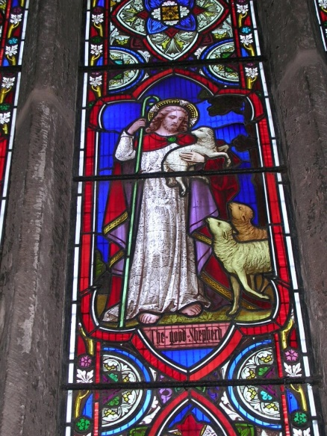
The lost sheep (Luke 15:4-7) – play hide and seek games or make lift the flap books, ‘Can you find the lost sheep?’ Discuss the job of a shepherd and the qualities that make a good shepherd. You could use Godly Play to tell this story. Have the children ever been lost and then found by their parents?
Record in your floor book.

Use Plasticine/play dough to create different faces expressing the emotions of the shepherd throughout the story – ask the children to wonder how the shepherd felt when one of his sheep was lost. Take photos

Talk about God being like the good shepherd and how we are his sheep and he loves each one of us.

The lost coin (Luke 15:8–10) – make a headdress from foil coins. Make sure one has dropped off, so the children can then search for it. (The coin is comparable to an engagement ring). How do you feel when you have lost something? How do you feel when you find something you have lost? Have the children ever lost anything important? Record children’s comments in your floor book.


The sower (Luke 8:4-15) – Sow some seeds – mustard and cress, nasturtiums, sunflowers in some rich soil with water, some in dry earth without water and some on gravel with water. Watch what happens. Take Photos.

Relate this experience to the story of the sower. Jesus said that if we listen to the word of God and follow in His way we will grow strong. What does that mean? We need to be nourished by love, patience, kindness, joy and peace etc.
Repeatedly ask the question, ‘What was Jesus trying to teach us in this story?’ Listen to the children’s ideas. There are not necessarily any wrong answers. Record in your floor book.

Ask the children to bring into school their own Bibles or Bible storybooks for a display of favourite stories Jesus told. Enjoy sharing the stories together. Jesus told. Write captions below the story.
Ask the children to explain why they have chosen that particular story. Record in your floor book.

Additional suggestions for classroom provision

Book corner
- Lots of parable storybooks

Writing area
- Retell the stories and draw pictures in your floor book.

The Great Feast
- Make invitations and have a party. God invites everyone!

Outside area
- Hide and seek lost coins

Construction/sand/water/malleable
- The story of the wise and foolish builders – build houses using building blocks, one house on top of house bricks and one on a pile of sand. Use a watering can to make it rain and watch the house on the sand collapse.
- Make playdough sheep and hearts, talk about Jesus the good shepherd who loves us and cares for us.

Playmobil/small world
- Give the pupils opportunities to use playmobil figures and small world people to retell the stories. Make a display of photographs showing the children telling stories.

Role play
- Wrap each other in bandages, talk about times when they have been hurt and who helped them. Draw pictures in your floor book.

Creative area
- It may be possible to find real life ‘Good Samaritan’ stories from the newspaper. Stick these stories on foot shaped pieces of paper and create a display of the footsteps on a road.

