EYFS 5: Stories Jesus heard

Which stories did Jesus hear when he was a child?

Christian Concepts
God – Creation – Fall – PEOPLE OF GOD – Incarnation – Gospel – Salvation – Kingdom of God

The aim of this unit is to:
- introduce pupils to stories of the Old Testament and understand that Jesus would have heard these stories as he was growing up.

Christian Values
Faith, Courage, Trust

Key Vocabulary
Bible, Old Testament, God, Jesus, Creation, Noah, Joseph, Moses, Joshua, Gideon, Jonah, David, Goliath and Israelites

Key Questions
- Which stories did Jesus hear when he was a child?
- Do you like listening to stories?
- What are your favourite stories?
- Where and when do you hear stories?
- Who tells you stories?

Content to be covered in this unit
- Hearing stories from the Old Testament that Jesus probably would have heard as a boy, choose from Noah, Joseph, Moses, Joshua, Ruth, Jonah, or Daniel.
- Exploring the feelings and characteristics of the people in these stories.

Objects for your Chatterbox
- Multi coloured fabric
- A Scroll
- A doll in a basket
- A lion
- Old Testament Bible storybooks
- A wedding photo
- A kings crown
- A knitted biblical character
- A rainbow
- A brick
- A hammer and nails (plastic)
- Bible Eggsplorer characters (see Bible Eggsplorers – Home | Facebook)
- A Bible
- Pictures of creation
- A Whale

To Begin with (First Lesson)
Chatterbox
Open the Chatterbox together and discover what is inside. The children take turns looking at and handling the objects. The conversation and questions will generate ideas for the learning activities, make notes as you chat and your planning has begun. The children’s ideas, comments, questions, work, pictures, writing and photos are all to be recorded in one giant book (floor book). Everyone contributes either directly onto the pages or by sticking paper, objects, photos or post-its into the floor book. This book is the record of the RE that has taken place and will form the basis of your assessment.

And/or Clever Cub
Use the Clever Cub storybook Clever Cub learns about love by Bob Hartman ISBN 978-0-8307-8253-6
Clever Cub arrives in your classroom with a story to share and a baby doll in a basket. He also has with him his favourite bedtime storybook and a collection of his favourite Old Testament stories.
In discussion about the different ways we can show we love someone Mama Bear tells Clever Cub the story of Moses being put in the basket on the River Nile a strange thing for a mother to do, but was in fact a great act of love.
This is a story Jesus would have listened to when he was a boy. Clever Cub has brought lots of stories with him that Jesus would have heard. They are all Bible stories from the Old Testament. These stories are all part of God’s Big Story and tell us about the People of God. Highlight on your ‘God’s Big Story Frieze’ where they can find the People of God.
Clever Cub also wants to tell his friends all about the Bible stories he listens to online, the Blackburn Diocesan Board of Education Podlets Podlets series 2 includes 10 stories Jesus would have heard as a boy.

Text Impact Connection
Explore and Discover Lesson Content

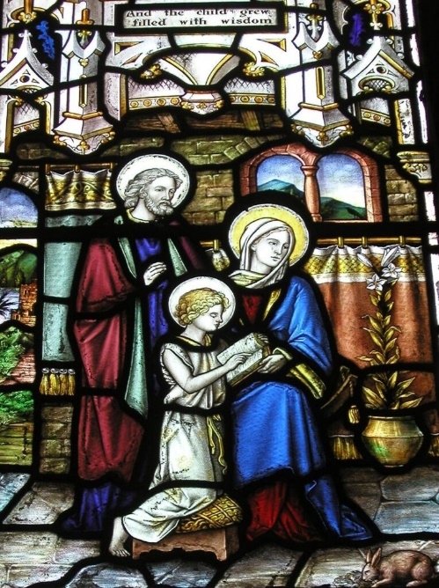
Discuss with the children their experiences of listening to stories.
When do they listen to stories?
Draw a picture of themselves listening to a story. Who is telling them the story? Discuss where and when the children usually listen to stories. Do they enjoy stories? Why? What are their favourite stories? Why?
Record in your floor book.

Make a display of their favourite story books.
I wonder if Jesus listened to stories? Which stories did he listen to? Why did he not hear the stories of Elmer, The Gruffalo or The Very Hungry Caterpillar? Do you think he has heard these stories now?
Make a collection of favourite Old Testament stories, set up a really comfortable and a special place in which to read them. Perhaps make a story tent by draping fabric overhead with interesting mobiles hanging down. The children could make the mobiles using pictures from the stories.
The persona dolls, Tom and Tessa could join you in your story tent and join in your discussion.
Are there any Bible stories that the children already know? What Bible stories did Jesus know?
Are there any questions the children would like to ask about the stories? Record in your floor book
Stories you could enjoy:
- Moses is found in the tall grasses.
Use a Moses basket full of props to tell the story, e.g. blanket, bulrushes, princesses crown, doll. Put the basket in the story area. How would the children have felt if they had been the princess finding the baby? Record in your floor book
- Daniel in the lions’ den. Make collage lions. Daniel was brave. They can draw a picture of a time when they were brave. Record in your floor book
- Tell the story of Ruth and celebrate the wedding of Ruth and Boaz. Take photos.
- Noah – focus on the rainbow of promise at the end of the story rather than the destruction of the world! Noah was obedient. Are we always obedient? Record in your floor book
- Joseph – his father gave him a very special gift. Talk about the children’s experiences of gifts, giving and receiving. Record in your floor book.
- Joshua – act out the story. Take photos.
- Jonah – imagine life inside the smelly whale/big fish. What did Jonah do in there? Make a fish puppet that swallows Jonah and then spits him out! Take photos.

Read several retellings of the same Bible story. Pick out and discuss the key characteristics of the people in the story and link them to the children’s own experiences. Obedience, courage, faith in God, trust, using gifts and talents, fear, confidence, forgiveness and saying sorry etc.
After reading the Bible stories, discuss questions such as ‘if you had been there what would you have done?’ ‘Why was x a hero?’ ‘Do you think ‘x’ should have done that?’ Why?
Record children’s comments in your floor book.

If you could travel back in time which of the stories would you like to be in? Why? Record in your floor book
Ask pupils what part of the story they liked best. Record in your floor book.
What part of the story did they think was most important?
Make a book of the children’s favourite stories and a book of the stories which may have been Jesus’ favourite.
The stories all teach us something about the nature of God. Emphasise this as you talk about the stories. God is always with us, God is faithful, God has a plan, God protects us, God listens and we can trust God.
Invite a someone from Christchurch to your special storytelling place, to tell their favourite Old Testament story. Ask them to explain why it is their favourite story. Give the children opportunity to tell the visitor their favourite story. Take photos.

Additional suggestions for classroom provision

Book corner
- Lots of Old Testament storybooks

Writing area
- Write prayers on lion shaped pieces of paper.
- Make invitations for the wedding of Ruth and Boaz.

Role Play
- Put Bible character costumes in your role play area and observe! Take photos

Sand/water/malleable
- Explore emotions within the stories and express them through making faces using play dough.
- Bible Eggsplorers activities

Creative area
- Make mobiles for your story tent. Make doves and sparkly rainbows.
- Paint coloured stripes on Joseph’s coat.
- Jesus’ books would have been scrolls. Look at and handle carefully a Torah Scroll.
- Make scrolls full of pictures from the Old Testament stories.

Construction
- Build Jericho and the city wall using building bricks and then then knock down the wall!
- Use playmobil people as Joshua and the other characters to act out the story. Take photos

Outside area
- Find a special outdoor place, be aware of the sounds around and then listen to a story Jesus heard.
- Draw pictures from the stories with chalks.

