EYFS 4: Christmas

How do Christians Celebrate Jesus’ birthday?
Christian Concepts
God – Creation – Fall – People of God – INCARNATION – Gospel – Salvation – Kingdom of God

The aim of this unit is to:
- explore the nativity story in a variety of ways and ensure pupils know that Christmas is the celebration of Jesus’ birth.

Christian Values
Love, Joy, Hope

Key Vocabulary
Christmas, Jesus, Bethlehem, Mary, Joseph, shepherds and star

Key Questions
- What is a birthday?
- When is your birthday?
- In what ways do you celebrate your birthday?
- How do Christians celebrate Jesus’ birthday?
- Why was Jesus a special baby?

Link to Understanding Christianity
Understanding Christianity Unit F2 Why do Christians perform nativity plays at Christmas?

Link to World Faiths
Why do Hindus light candles at Diwali?

Content to be covered in this unit
- Discussing all the different ways in which we celebrate the birthdays of people of all ages.
- If possible arrange the visit of a baby to your classroom and/or a collection of baby items.
- Talk about the ways in which the children will be celebrating Christmas.
- Tell and retell the story of the nativity several times using different storytelling techniques.
- Clearly emphasise that for Christians Christmas is a celebration of the birth of Jesus.
- Look at the ways in which the local church is going to celebrate Christmas. Invite the vicar/minister and/or a member of the congregation to visit and describe the celebrations.
- The story of Anna and Simeon (Luke 2:21-40)
- Exploring the Hindu Festival of Diwali

Objects for your Chatterbox
- Pictures of the nativity from around the world using different styles of artwork.
- 3D nativity scene characters including an angel and sheep
- Baby boy birth congratulations card
- A handful of straw
- A birthday cake candle
- A happy birthday banner
- A wrapped gift
- A heart
- A Christmas Card
- A dummy or rattle
- A photo of an old person with a baby
- Christmas songs about the Nativity Story
- In order to explore World Faiths in this unit you will need these additional items for your box
- Diva lamps (Diwali)
- Tea Lights
- Glow sticks
- Rangoli patterns

To Begin with (First Lesson)
Chatterbox
Open the Chatterbox together and discover what is inside. The children take turns looking at and handling the objects. The conversation and questions will generate ideas for the learning activities, make notes as you chat and your planning has begun.
The children’s ideas, comments, questions, work, pictures, writing and photos are all to be recorded in one giant book (floor book). Everyone contributes either directly onto the pages or by sticking paper, objects, photos or post-its into the floor book. This book is the record of the RE that has taken place and will form the basis of your assessment.
And/Or Clever Cub (a teddy bear)
Use the storybook ‘Clever Cub welcomes Baby Jesus’ by Bob Hartman ISBN 978-8307-8156-0
A very excited Clever Cub arrives in your classroom with a Christmas bag full of things including his story, that he would like to share with the children.
Items in Clever Cub’s bag:
- Stars and angels Christmas decorations
- A nativity scene in a gift box
- Christmas cards
- Cake and candles
Clever Cub begins by telling them that he is really looking forward to celebrating Christmas and soon he will be helping his mum to decorate their home, He has brought to show them some of his favourite Christmas decorations. The decorations are all stars and angels because they remind him of when his mama told him the story of Christmas for the first time.
After telling the story remove from the Christmas Bag the nativity scene in a gift box. Clever Cub can explain that Christmas is celebrated because Christians believe that Jesus was born as a baby on earth as a gift from God to everyone, God was showing that he loved his people and wanted to be friends with them again. (God’s Big Story).
Help Clever Cub to set up the nativity scene in your classroom.
Clever Cub has also brought with him some Christmas cards, birthday candles, and a cake. This is because Christmas is the celebration of Jesus’ birthday.
Discussion about birthdays, and celebrating the arrival of new babies can flow on form here.
Clever Cub doesn’t have any photos with his family when he was born so perhaps you could paint one for him.

Text Impact Connection

Explore and Discover Lesson content

Tell children fictional stories about a new baby arriving. Share their experiences of new babies. Arrange for a baby to come into school and/or have a collection of ‘baby’ things e.g. bottle, dummy, rattle, nappy, clothes so that you can talk about the needs of new babies.
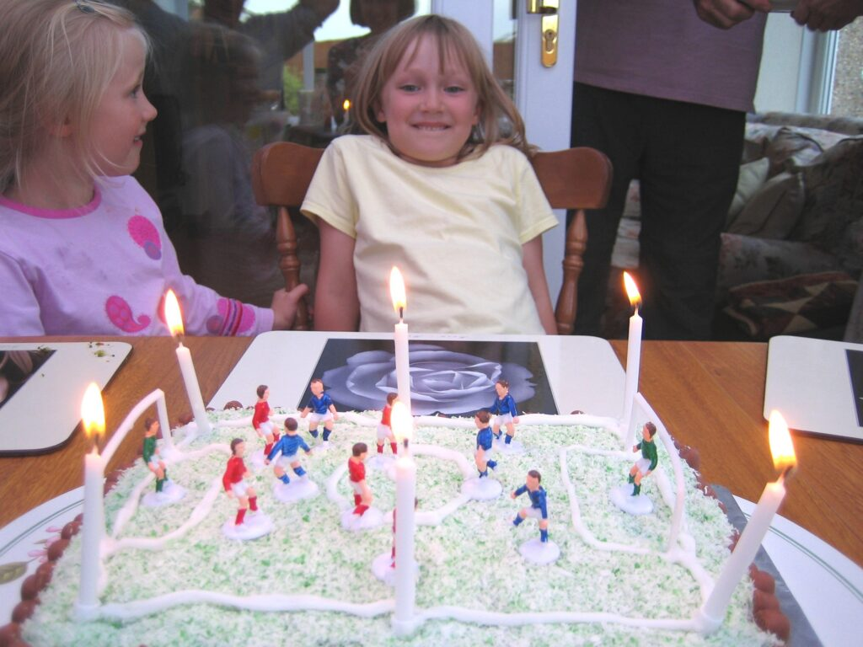

Every year we remember the day we were born – our birthday. How do we celebrate? Make a collection of objects that we use in our celebrations. Use circle time to discuss children’s birthday experiences.
Record children’s comments in your floor book

Dress two baby dolls one in modern clothes and one as a baby in Jesus‘ time. Talk about the differences. Ask children to bring in photographs of themselves as a new born baby. Were they wrapped in swaddling bands and laid in a manger? Why not?
Tell the children the nativity story using different books and look at different pictures of the nativity scene. Compare these to pictures of babies today and the fictional stories read earlier. Are there any similarities and differences? One big similarity is that all babies change the world and life of people around them and so did Jesus. Jesus was a special baby. At Christmas Christians remember Jesus’ birthday.

Watch embedded BBC film clip of the Christmas story in online unit (3-4 minutes).

Together make a story sack – angel, donkey, star, straw, shepherd’s headdress and involve children in retelling the story. Take photos

If you are using Tom and Tessa persona dolls they could bring the story sack with them to your classroom and help in the retelling of the nativity story.
Make a giant “lift the flap” display “Who is in the Stable?”
Take a photo of the display

Ask the children to sequence pictures of the nativity story and retell the story.
Which part of the story do they like best?
Which part of the story is most important?
Record in your floor book
Ask the children to name the characters in the nativity story using the 3D figures from your nativity scene.
How would we feel if our birthday is forgotten? Read a story where friends appear to have forgotten someone’s birthday. In a circle time discuss that person’s feelings. Often people forget that Christmas is Jesus’ birthday. Why? Discuss this with the children. How can we help them remember?
Record children’s comments
Have a birthday party for Jesus – involve the children in preparing food. Sing Christmas songs and carols.
Take photos

Tell the story of Anna & Simeon (Luke 2: 21-40).
How would you have felt if you had waited a long time for something and then it arrived? Why was Jesus so special? It was because when he grew up he changed peoples’ lives. How?
Record in your floor book.
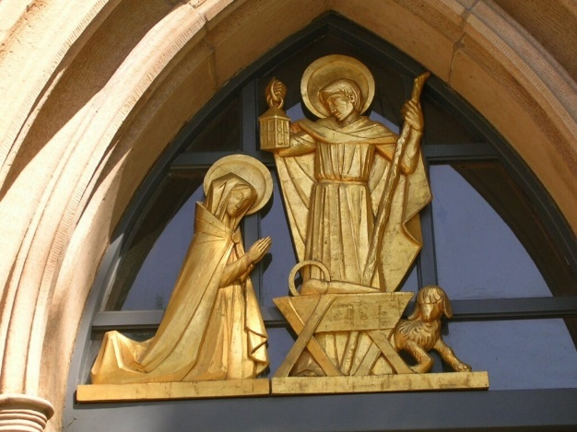
If in the Big Story the birth of Jesus is. The incarnation is panel 5 of the big frieze. Christians believe Jesus is the promised Messiah, the Son of God. Everyone is waiting for him, the prophets announced he was coming.

Investigate the ways in which the local Church is going to celebrate Christmas, invite the vicar/minister and/or a member of the congregation to visit and describe the celebrations.
Record in your floor book.
For additional lesson content see Understanding Christianity Unit F2 pages 4 and 5

Link to world faiths:

Why do Hindus light candles at Diwali?
Background information for Teachers
The festival of Diwali is celebrated by Hindus in India and all around the world in October or November. For Hindus it marks the beginning of the New Year and is either a 3-day or 5-day holiday depending on where you come from. Note: There is no connection between Christmas and Diwali other than they both take place around the same time of year and celebrations involve the giving of gifts and colourful decorations. The two festivals are celebrating entirely different events in history however there is a similarity as both include the concept of light overcoming darkness.
Diwali is known as the ‘festival of lights’ and houses, shops and public places are decorated with small earthenware oil lamps called divas. The word Diwali means ‘rows of lighted lamps’. The festival celebrates the victory of good over evil, light over darkness and knowledge over ignorance.
As part of the celebrations Hindus retell the Diwali legends, one of which tells how Rama rescues Sita from the evil demon king Ravana. During this 3-5 day festival many Hindus honour Lakshmi, the goddess of wealth. Lamps are lit to help Lakshmi find her way into people’s homes, and windows and doors are left open.

The introduction to Diwali may have been generated by conversation about the items in your chatterbox. If not then Diwali could be introduced by Clever Cub having a friend who is celebrating Diwali and Clever cub wants to know all about it.
Or
you could use a Hindu persona doll who has come to visit Tom and Tessa.

Watch embedded BBC clip, The Hindu story of Rama and Sita (5-6 minutes)

Have a look at the following items in your Chatterbox
- Diva lamps (Diwali)
- Tea Lights
- Glow sticks
- Rangoli patterns
Do the children know what these things are?
Diwali is a very exciting and colourful festival. It is a time for………
- spring-cleaning the home,
- wearing new clothes;
- exchanging gifts (often sweets and dried fruits) and preparing festive meals;
- decorating buildings with fancy lights;
- huge firework displays;
- drawing rangoli on the floors (rangoli are patterns)

Watch embedded Cbeebies clip, My First Divali in online unit (3 minutes)

The children can enjoy painting rangoli patterns, listening to the story of Rama rescuing Sita, retelling the story using puppets and making their own diva lamps from clay.
Record in your floor book and take photos

Additional suggestions for classroom provision

Creative Area
- Look at a variety of Christmas cards. The children can then make their own card that reminds people that Christmas is Jesus’ birthday.
- Make collages which sparkle and shine – use glitter, sequins, paper and tinsel as a celebration of Christmas.
- Show the children great works of art that depict the nativity scene, a google search of artwork depicting the nativity will provide a wealth of possibilities. Include pictures from all around the world. The children can then create their own masterpieces.

Book corner
- Place lots of children’s books of the nativity story in the book corner.
- Use puppets, nativity figures and pictures of each character to tell the story from their point of view.

Role Play
- turn the role play area into the stable, use the children’s pictures from the creative area as a back drop and to set the atmosphere. Take photos

Sand/water/malleable
- Using salt dough create nativity figures. Let each character tell its own story. Take photos

