EYFS 1: I am Special

Why are we all different and special?

Christian Concepts
GOD – CREATION – Fall – People of God – Incarnation – Gospel – Salvation – Kingdom of God
The Aim of this Unit is to:
- give pupils an understanding that they are unique and special.
- to know that Christians believe that they are loved, valued and made by God.

Christian Values
This unit does not clearly enrich any one particular Christian value. It stresses instead how much God loves and values us and the value of self-worth.

Key Vocabulary
God, love, father and unique

Key Questions
- How do we know that we are special in the eyes of God?
- How do we know that God is our heavenly father?
- What are my favourite things?
- Why are names important?

Link to World Faiths
Islam

Content to be covered in this unit
Talking about God as Heavenly Father and that He makes each one of us different and special, He knows us and loves us.
An opportunity for children to think about and discover more about themselves, their likes, dislikes, physical features, abilities etc, including looking at handprints, footprints and fingerprints. Talk about emotions and the experiences related to them
The importance of our names and the names people of faith give to God
Objects for your Chatterbox
- Pictures of the faces of children from all around the world
- A thumbprint
- A book of names
- A mirror
- An old passport or ID badge
- Skin coloured crayons
- A Baby ultrasound scan picture
- A camera
- A book about feelings
- A door hanger or mug with a name on it
- A ‘my favourite’ nursery rhymes/stories book or CD Storybook
- You’re all my Favourites by Sam McBratney ISBN 978-1-84428-515-0
To Begin with (First lesson):
Chatterbox
Open the Chatterbox together and discover what is inside. The children take turns looking at and handling the objects. The conversation and questions will generate ideas for the learning activities, make notes as you chat and your planning has begun.
The children’s ideas, comments, questions, work, pictures, writing and photos are all to be recorded in one giant book (floor book). Everyone contributes either directly onto the pages or by sticking paper, objects, photos or post-its into the floor book. This book is the record of the RE that has taken place and will form the basis of your assessment.
And/Or Clever Cub
Use the storybook ‘Clever Cub Explores God’s Creation’ by Bob Hartman ISBN: 978-0-8307-8153-9
Clever Cub arrives in your classroom with a story to share and the little book he has made. Print this sheet and then use these instructions to create Clever Cub’s Creation book.
At the end of the story Mama bear tells Clever Cub that God made people. This is your lead into talking about the ways in which each of us is different and special. Connections could be made to several objects in the chatterbox.
Clever Cub explores creation and so can you! The children can make their own little books full of pictures of creation concluding with a picture of themselves. Use these instructions to create the booklet.
Clever Cub’s story is also the beginning of God’s Big Story. Highlight on your God’s Big story frieze that creation is the first panel.

Text Impact Connection

Explore and Discover – Lesson Content
Make pictures using thumbprints, fingerprints, handprints and footprints in your floor book.
Look at thumb and finger prints through a magnifying glass. What can you see?
Record in your floor book.
God made each one of us the same but different. We are unique. How do we know? Because the Bible tells us on many occasions that we are made in the image of God, (Genesis 9:6) he knows everything about us and he loves us. (Deuteronomy 23:5, 1 John 4:7)
Psalm 139:14 – I praise you because I am fearfully and wonderfully made; your works are wonderful, I know that full well.
Guess how many hairs are on your head?
Matthew 10:29 – 31 – God even knows how many hairs are on our heads!
Recommended story book ‘When God Made you’ by Matthew Paul Turner ISBN 978-1-60142-918-6

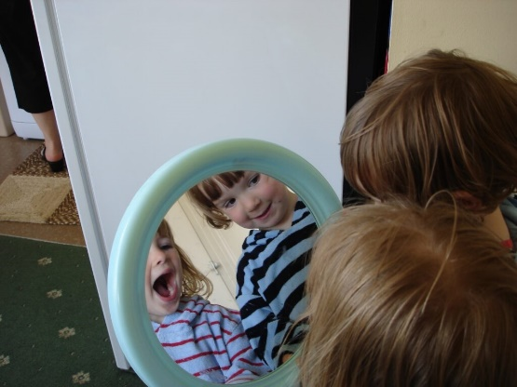
Who can you see in the mirror? Place a mirror inside a box with a lid. Tell the children that if they look inside the box they will see, something amazing and unique that God has made.

Ask the children what colour they are. Everyone is different and no-one is pink or white. Look at the skin coloured crayons (you can also buy skin coloured play dough and paper) can they find one that matches their skin colour more closely than the usual coloured crayons? God’s children are a rainbow of colours. Look at the pictures of the children’s faces, find more pictures in magazines and make a collage; we are all the same but different. (Don’t forget to include children with disabilities).
Record in your floor book.
Recommended story book – ‘Happy in our skin’ by Fran Manushkin ISBN 978-0-7636-7002-3

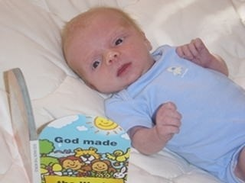
We all begin as a baby and then grow and develop. Ask a mum with a new baby to visit school. Marvel and wonder at the miracle of tiny ears, hands, toes. Make comparisons between what the baby can/can’t do now. What more do they need to learn? How much bigger will they grow? Place small baby shoes next to their school shoes. Wow! What are the children looking forward to being able to do as they grow up? I wonder what God’s plan is for you?
Take photos and record in your floor book.

Names are very important. Why?
Who taught you to write your name?
How did you feel when you were first able to write your name? Can you read your name?
How do you feel when someone knows your name and they remember you?
Who chose your name? Why did they choose that name? Is there a story about how your name was chosen? What does your name mean? Everyone’s name is written on the palm of God’s hand (Isaiah 49:6). Make a giant hand shape out of paper and write the name of every member of the class, including adults, on it. Now draw around your hands and write the names of people special to you on your hand shapes. Write sentences ‘x is special because….’ Record in your floor book.

Learn and sing the Fischy Music song – Written on the palm of God’s hand (Down to earth CD available from www.fischy.com)

Make ‘All about me’ name plates illustrated with the children’s favourite colours, things, animals etc.
Recommended Story Books ‘My name is not refugee’ by Kate Milner ISBN 978-1-911370-06-2
‘The Name Jar’ by Yangsook Choi ISBN 978-0-440-41799-6

God is called Father, Son and Holy Spirit, the Trinity. God the Son is called Jesus and he has names King of Kings, Prince of Peace and Lord of all. Lots of posters listing the names of God and Jesus can be found using a google image search.
Explore feelings and emotions through discussion and stories. You could use a story and the characters from a Disney film series as a starting point, such as Shrek, Cars, Ice Age, Happy Feet, Toy Story, Finding Nemo, Frozen, Trolls, Encanto or Luca, all these films have characters who experience a wealth of emotions that would enable children to discuss feelings comfortably from a distance but could also free them to be open and relate to the emotions personally. The film ‘Inside Out’ is a Disney Pixar film all about emotions, specifically joy, fear, anger, disgust and sadness.
I felt sad like Shrek when……………
I feel like dancing (like Mumble) when……………….
They can tell you about being happy when……………………..
They could paint and then explain a sad or angry picture.
Record in your floor book.

If you are using Tom and Tessa, the persona dolls, they can bring their ‘passports’ and talk about their likes, dislikes and feelings etc

Link to world faiths:
Islam

Investigate
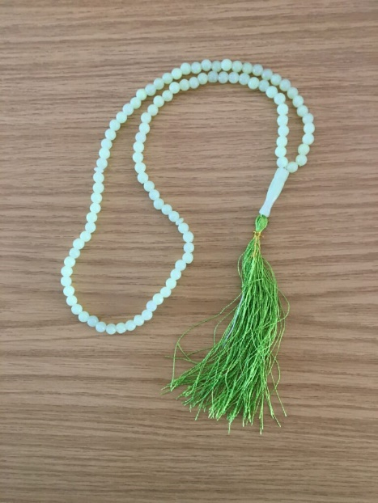
Place a string of Islamic Prayer beads in a fabric bag and invite the children to touch and shake the bag while talking about what it might contain. Allow them to feel inside the bag and eventually ask a child to remove the beads so that everyone can see the beads clearly.

Ask and Wonder
I wonder what this might be?
I wonder what it is for?
I wonder who they belong to?
Record in your floor book

Introduce the word ‘subhah’ and count the beads (there are usually 99) explain that each bead represents a name that is given to God by Muslims. These names are constant reminders of the characteristics of God and how he wants Muslims to behave. These names are very special and important. Muslims often carry beads like these in their pockets and as they move their fingers across them it is a reminder of God’s names and how they should be behaving. Posters of the 99 names of Allah can easily be found using a Google search

Additional suggestions for classroom provision

Book corner
- Stories about the arrival of new babies.
- Lots of ‘All about Me’ and ‘I am special’ books

Writing area
- Write the names of family members on a family tree.
- Make passports that include all sorts of information about the child such as places the children would like to travel to, people they would like to meet, favourite toys, family members etc. As well as ‘I am special’, ‘We’ are special so a passport for the class as a whole could be made.

ICT/Technology
- Let the children take photos of each other and create a wall display that introduces the class to each other and visitors. Hello my name is …………………. and I like……………………..

Outside area
- Make muddy footprints

Sand/water/malleable
- Make handprints in wet sand or play dough.

Creative area
- Create handprint pictures.
- Paint self-portraits, make mirrors

Construction
- Build homes

Role Play
- Place a mirror securely in the role play area with lots of dressing up clothes

