A Reading Guide for Parents
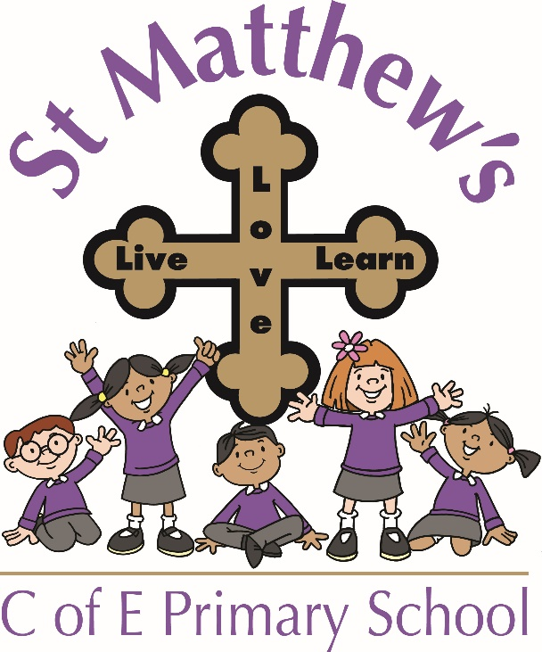

We’re more than just teachers and parents – We are a team around your child.
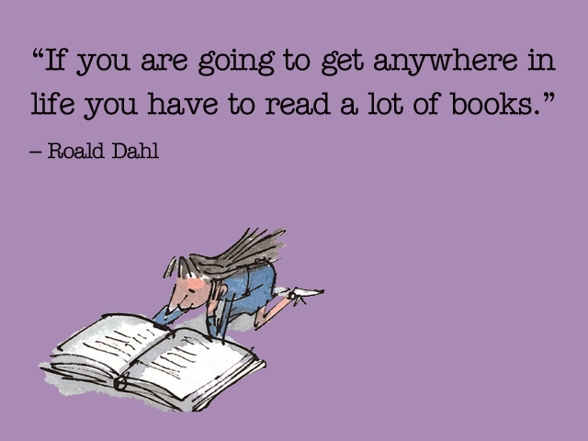
Why read?
Sharing a book with a child is fun - it's a time for closeness, laughing and talking together. It can also give children a flying start in life and help them become lifelong readers. booktrust.org.uk

Research proves that children who enjoy reading do better at school in all subjects.
Reading improves all of a child’s literacy skills and can offer them a lifetime of enjoyment and learning.
At St Matthew’s we aim to promote a love of reading and feel that children discovering books and how to use and enjoy them is crucial to their development.
We teach reading in a variety of ways - through guided reading sessions, one to one reading, group reading and whole class work in English lessons. We cover a variety of topics, choosing books that support and challenge them to explore further.
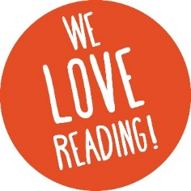

First things first…
Helping your child with reading isn’t just about listening to him / her reading a school reading book, although this is of course vitally important! Here are some other ways of developing reading skills in your child:

- Talk and listen to your child

- Make time to read. Read a bedtime story with your child every night. Encourage them to share reading with grandparents, brothers and sisters and aunts and uncles.

- Make time for discussion – of a TV programme, a news item, a film, during a walk, over a meal, in the car, at bath-time

- Read stories, poems and other texts aloud to your child – and don’t deny yourself the pleasure of reading more challenging texts to older children

- Read yourself - Let your child see you reading for purpose and pleasure
- Visit the library - it’s free to join! All libraries have children’s sections. Many also have regular storytelling sessions

- Listen to stories on CDs, the radio, the internet

- Give your child access to a wide variety of written material: books, magazines, websites, recipes, instructions, TV guides, catalogues, games

- Keep books safe. Make your child their own special place to keep their books. Show them how to turn pages carefully.

- Sing nursery rhymes with your child or retell traditional tales.

- Point out words all around you. Help your child to read the words around them: on food packets in the supermarket, on buses, in newspapers, in recipes.

- Keep in touch with school. Make sure your child swaps their home reading books regularly at school and try to make a regular time slot of about 10 minutes to hear them read.

- If English is not your family’s first language: You can buy dual language books. You can talk about books and stories in any language.

Reading with your child at home is a crucially important way to support their learning.
Reading books together, reading to your child, hearing them read, discussing reading technique, stories, poems and non-fiction texts are all key ways to help your child to develop into an able and accomplished reader and writer.

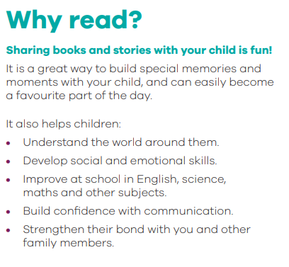
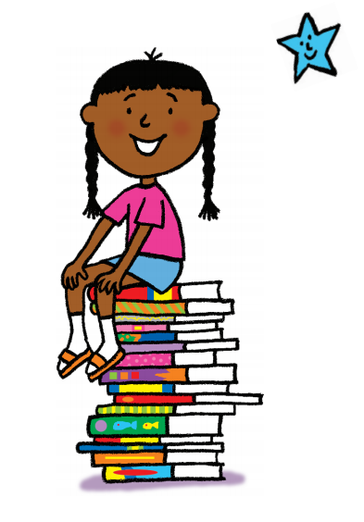
How?
General tips
Remember that children need to read a variety of texts - stories, factual books, poems, etc. They also love being read to by adults, particularly if you can change your voice to match the characters! If you show children you enjoy reading it will have a positive impact.
Sharing a book with a child
Make sure your child has a comfortable, quiet place to sit. Distractions such as TV can make it difficult for children to concentrate. Give the book to your child for five minutes so they can look at it alone. This allows the child to explore the text and pictures independently before starting to read. Read the title together and ask them to tell you what they think the story will be about and answer any questions they may have before beginning. Remember talking about books is as important as reading them. Children need to have enthusiasm for texts, so allow them to choose their own as well as their school reading books.

Children reading aloud;
It is important that children, particularly in the Early Years and Key Stage 1, are given the opportunity to read aloud to an adult as often as possible. It improves their decoding and listening skills.

We ask that you read with (and sign their record book) at least 4 times a week, preferably more.

A sample page is at the back of this guide. Help your child to sound out and blend any unfamiliar words. If they are still unsure, tell them the word and explain what it means. Then read the sentence again together. Remember to use praise a lot and tell them why they have done well - “I really enjoyed listening to that sentence because you made it sound so exciting!”

Older children may feel that they enjoy reading on their own more and prefer to read in their head instead of aloud to an adult. This is usually evidence that they are enjoying the reading experience and are skilled and independent enough to read alone. The focus for a parent at this point should be more on discussion of comprehension and providing an environment where sharing opinions about books is valued at home.
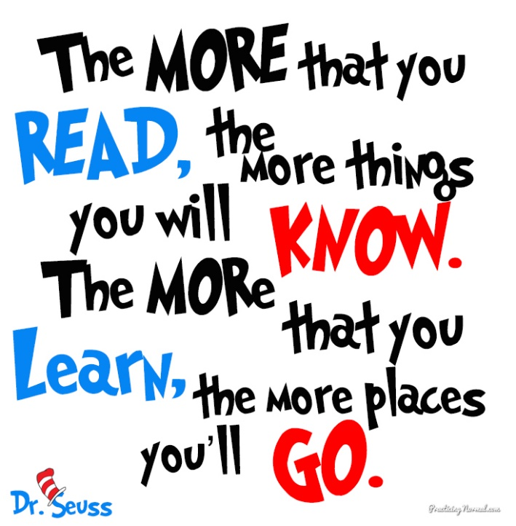
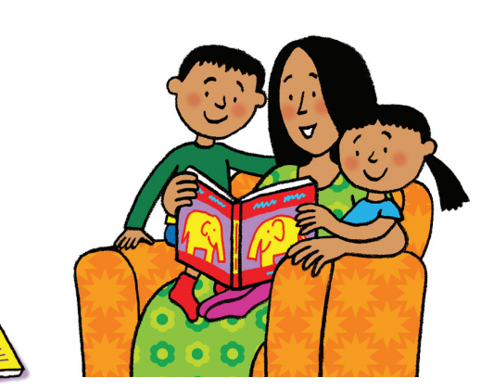

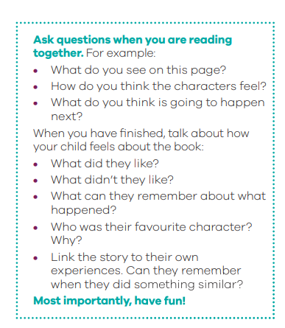
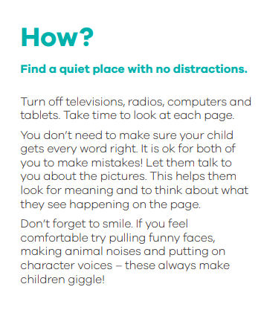
Strategies for Helping with Decoding
As you know, one of the vital first steps of early reading is to be able to ‘sound out’ words and blend sounds together in order to read them. This is called ‘decoding’. During the early stages of learning to read, children are given books which they are able to decode using phonic strategies that they have been taught at school. As they become more confident readers, they will continue to use these strategies and develop many others. Some of these strategies are listed below:
• ‘Blending’ or ‘sounding out’ whole words, particularly in the early years: ‘ch – o – p’, ‘p – l – ay’,
‘t – r – ai – n’
• Recognising common endings (s, -ing,- ed, -er, -tion, -able) and prefixes (un-, de-, in-)
• Finding the root word within more complex words (enthusiasm, subway, incoming, discontentment)
• Using syllables to break words down into chunks (mis-con-duct, ex-tra-or-din-a-ry)
• Recognising words ‘at sight’ (fluent readers read most words like this)
• Using picture clues.

TOP TIP: If you have paused to decode a word, it’s a really good idea to stop and re-read the sentence - so that you do not lose the sense of the text you are reading.
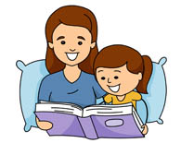
Comprehension
One of the most important parts of reading is comprehension. If a child can read fluently, but does not fully understand the story or text, then they struggle to enjoy or appreciate books. It is therefore essential that children have opportunity to discuss what they are reading. Open ended questioning such as; ‘Why do you think that happened?’ or ‘What makes you think that?’ will help with this. Asking children to tell you why or show you clues in the text/pictures can improve their inference skills dramatically. Below are some questions that could be used in a discussion with a child about a book:
Questions to ask before you read

- Can you look at the pictures and predict what you think will happen in this book?
- What makes you think that?
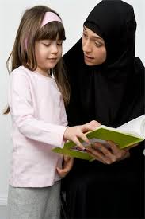
- What characters do you think might be in our story?
- Do you think there will be a problem in this story? Why or why not?
- Does the topic/story relate to you or your family? How?

Questions to ask during the reading

- What do you think will happen next?
- What can you tell me about the story so far?
- Can you predict how the story will end?
- Why do you think the character did _______?
- What would you have done if you were the character?
- How would you have felt if you were the character? (use different characters)
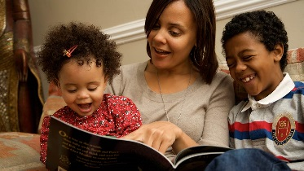
- As I read____________, it made me picture________ in my head. What pictures do you see in your head?
- As you read, what are you wondering about?
- Can you put what you’ve just read in your own words?

Questions to ask after reading

- Can you remember the title?
- In your opinion, was it a good title for this book? Why or why not?
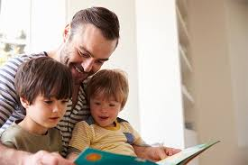
- Were your predictions about the story correct?
- If there was a problem, did it get solved?
- What happened because of the problem?
- Why do you think the author wrote this book?
- What is the most important point the author is trying to make in his writing?
- What was your favourite part of the story?
- If you could change one thing in the story, what would it be?
- Can you retell the story in order?
- If you were __________, how would you have felt?
- What is the most interesting situation in the story?
- Is there a character in the story like you? How are you alike?
- Why did you like this book?

Reading Record Books
Listed below are some comments which may help you when writing in your child’s reading record book to describe how your child has read to you at home (an example page is also included).
To build a realistic picture and encourage your child appropriately, it is essential for both parent and teacher to have an open and honest dialogue and as such, it is important to record both positive and developmental comments. The statements below are just a guide; please feel free to alter the wording and write what best suits your experiences. For more information, or if you have any questions, please do not hesitate to ask.

Possible comments for reading record books:

- Read familiar words independently.
- Able to predict what happens next in the text.
- Showed good understanding of the text
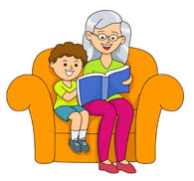
- Read with good expression.
- Worked out new words independently.
- Worked out new words by sounding them out.
- Discussed the story and characters well.
- Used good spoken expression
- Enjoyed reading this book a lot
- Self-corrected own errors independently
- Used the picture cues and the first sound of a word to work out words
- Read with fluency and expression
- Able to read this book with lots of help
- Struggled to work out a lot of the vocabulary
- Reading sounded robotic and stilted
- Struggled to concentrate.
- He/she made a number of errors because he/she was not looking carefully enough
- Would not read tonight
- Found this book too hard to read
- Created tension as he did not want to read
- Did not understand what he has read

If your child is reluctant to read that night
  - Try taking it in turns to read a page / paragraph / chapter.

  - Don’t expect perfection, especially if they have moved up to a higher band of books – gaining an overall idea about the book is more important than correcting every single mistake

  - Keep reading sessions short and enjoyable – make them a special part of the day!

- Write a brief comment in their record book – their teacher will do all that they can to help.

Useful Websites:

lovereading4kids.co.uk booktrust.org.uk
literacytrust.org.uk wordsforlife.org.uk/5-7
wordsforlife.org.uk/7-11 booksforkeeps.co.uk
oxfordowl.co.uk/for-home/


